|  |  |  |  |
| --- | --- | --- | --- |
| Year 12 Worksheet 1 – Formative Assessment 1 | | | |
|  | | | |
| **Name:** | **Teacher:** | **Score /5** | |
| **Comment:** | | | **Time allowed:**  **15 minutes** |

1. Two dogs are pulling on ropes held by their owner with forces of 200N each. If they are at right angles to each other (one pulling southeast, and the other pulling north east), calculate the resultant force on the owner.
2. 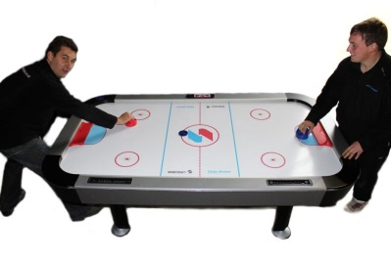A person playing a game of air hockey hits the puck with a velocity of 3.00 ms-1 into the north wall of the table at an angle of 45 degrees from the western side of the table. If and it rebounds at the same angle on the other side with a velocity of 2.00 ms-1, what is its change in velocity?

**[**

1. A steel ball bearing starts to roll down a slope angled at 33 degrees to the horizontal. What is the acceleration on the ball bearing if there is no friction?